LAB ASSIGNMENTS 3: SQS and SNS

What is AWS SQS?
Amazon Simple Queue Service (Amazon SQS) offers a secure, durable,
and available hosted queue that lets you integrate and decouple distributed
software systems and components.

Amazon SQS offers common constructs such as dead-letter queues and cost allocation tags.
It provides a generic web services API that you can access using any
programming language that the AWS SDK supports.

Instruction:
1: Creating SQS and creating messaging and consuming form UI
2: We will create a message and access from the code

3: We will do post request to send an message and message would be used by the consumers
Note: Delete SQS after demo And delete access key and secrete key

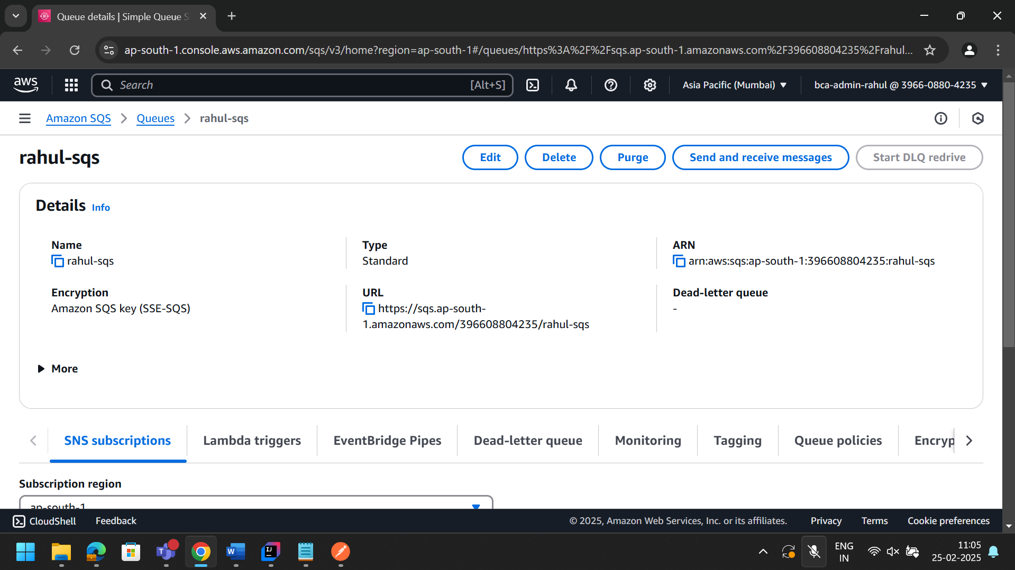

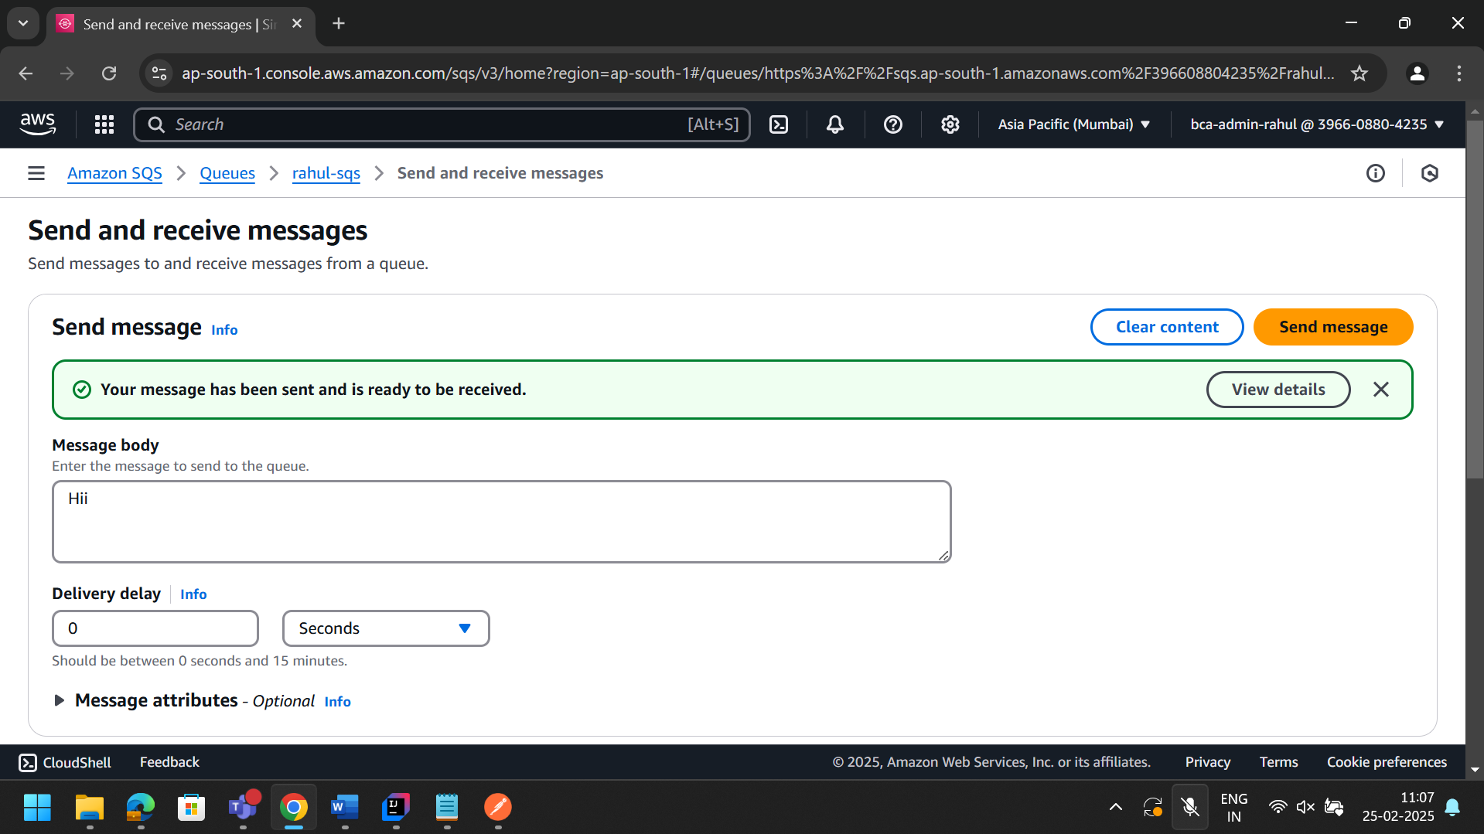

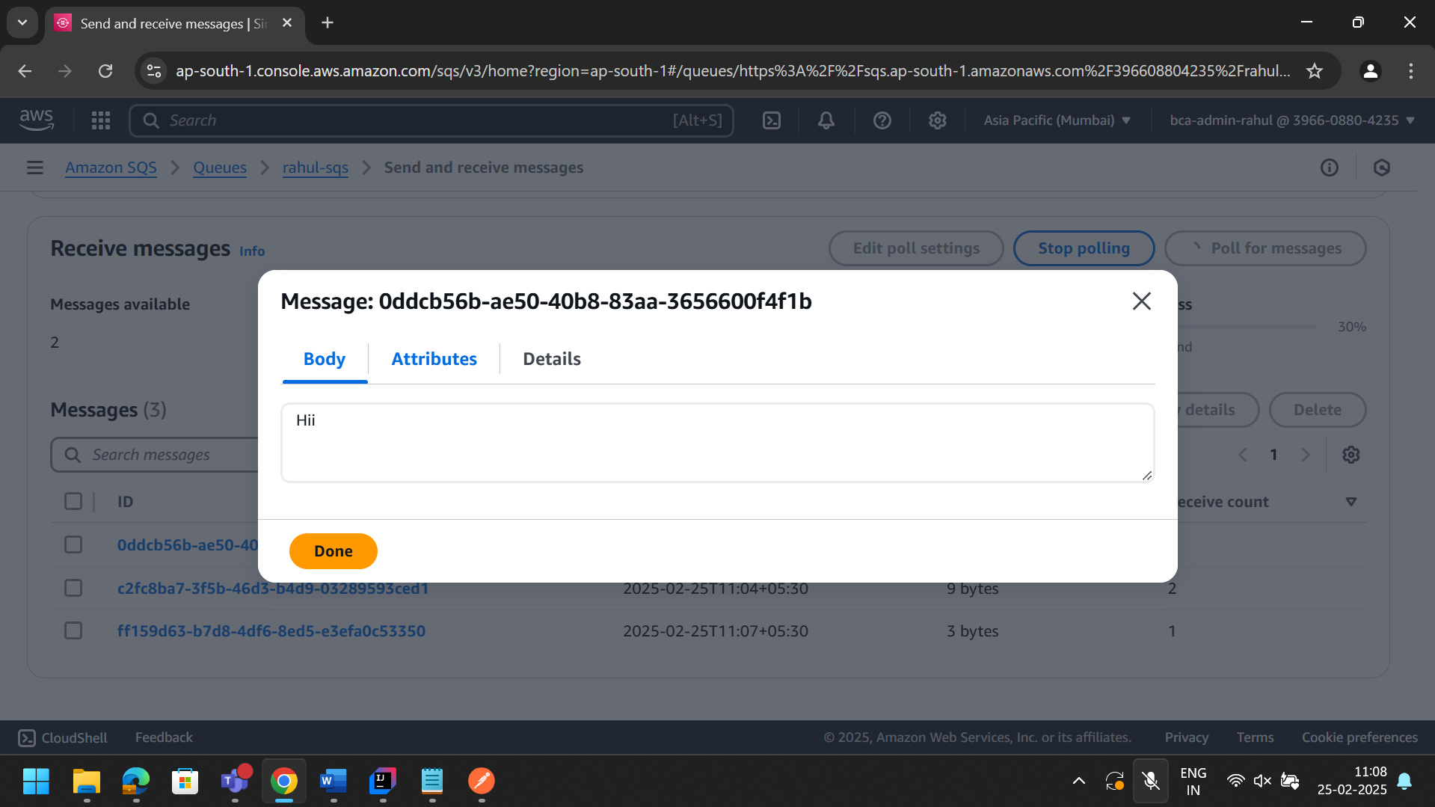

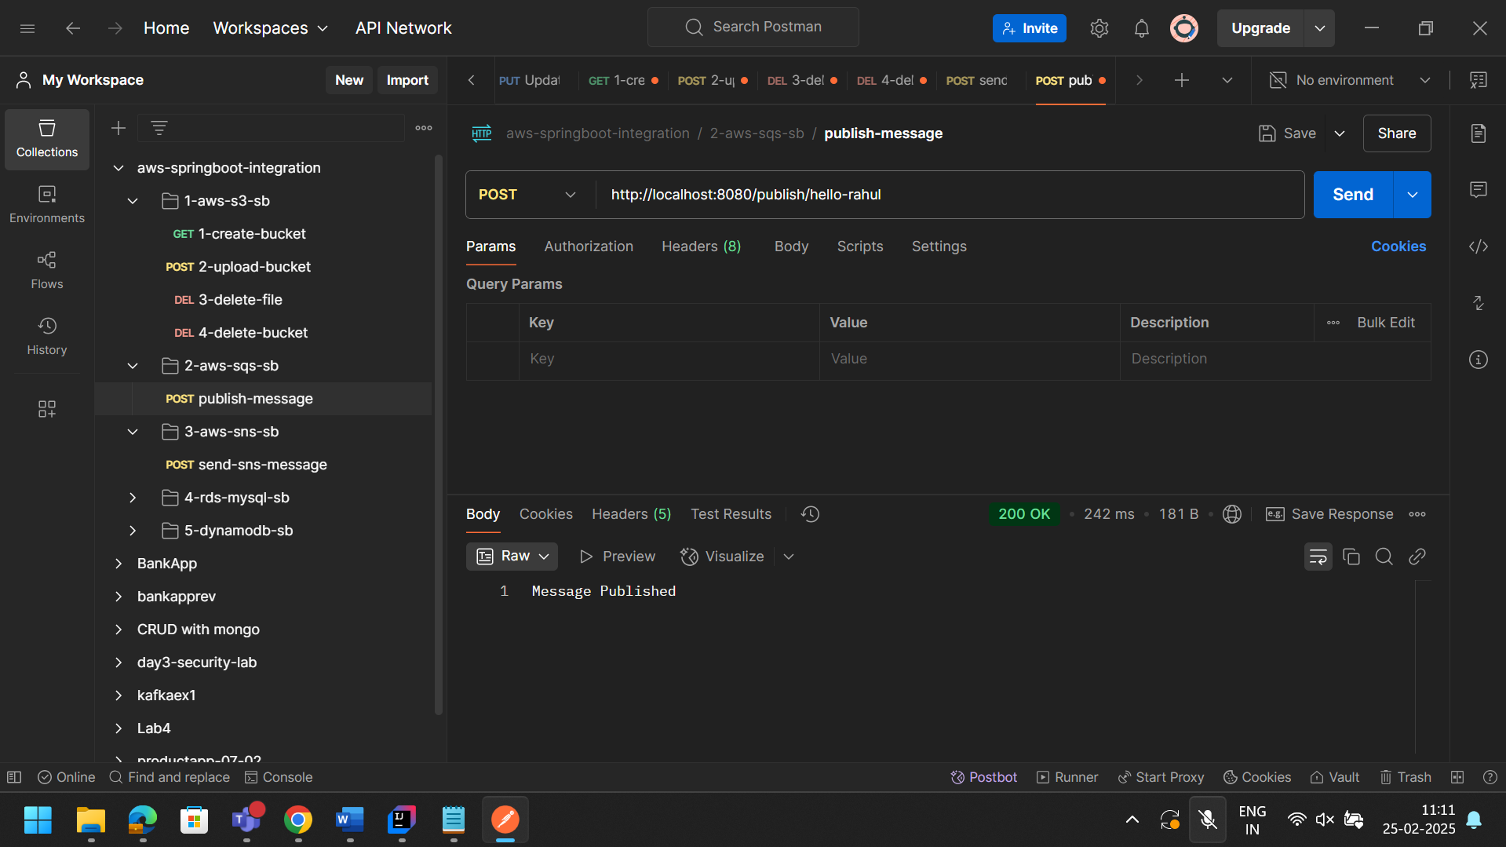

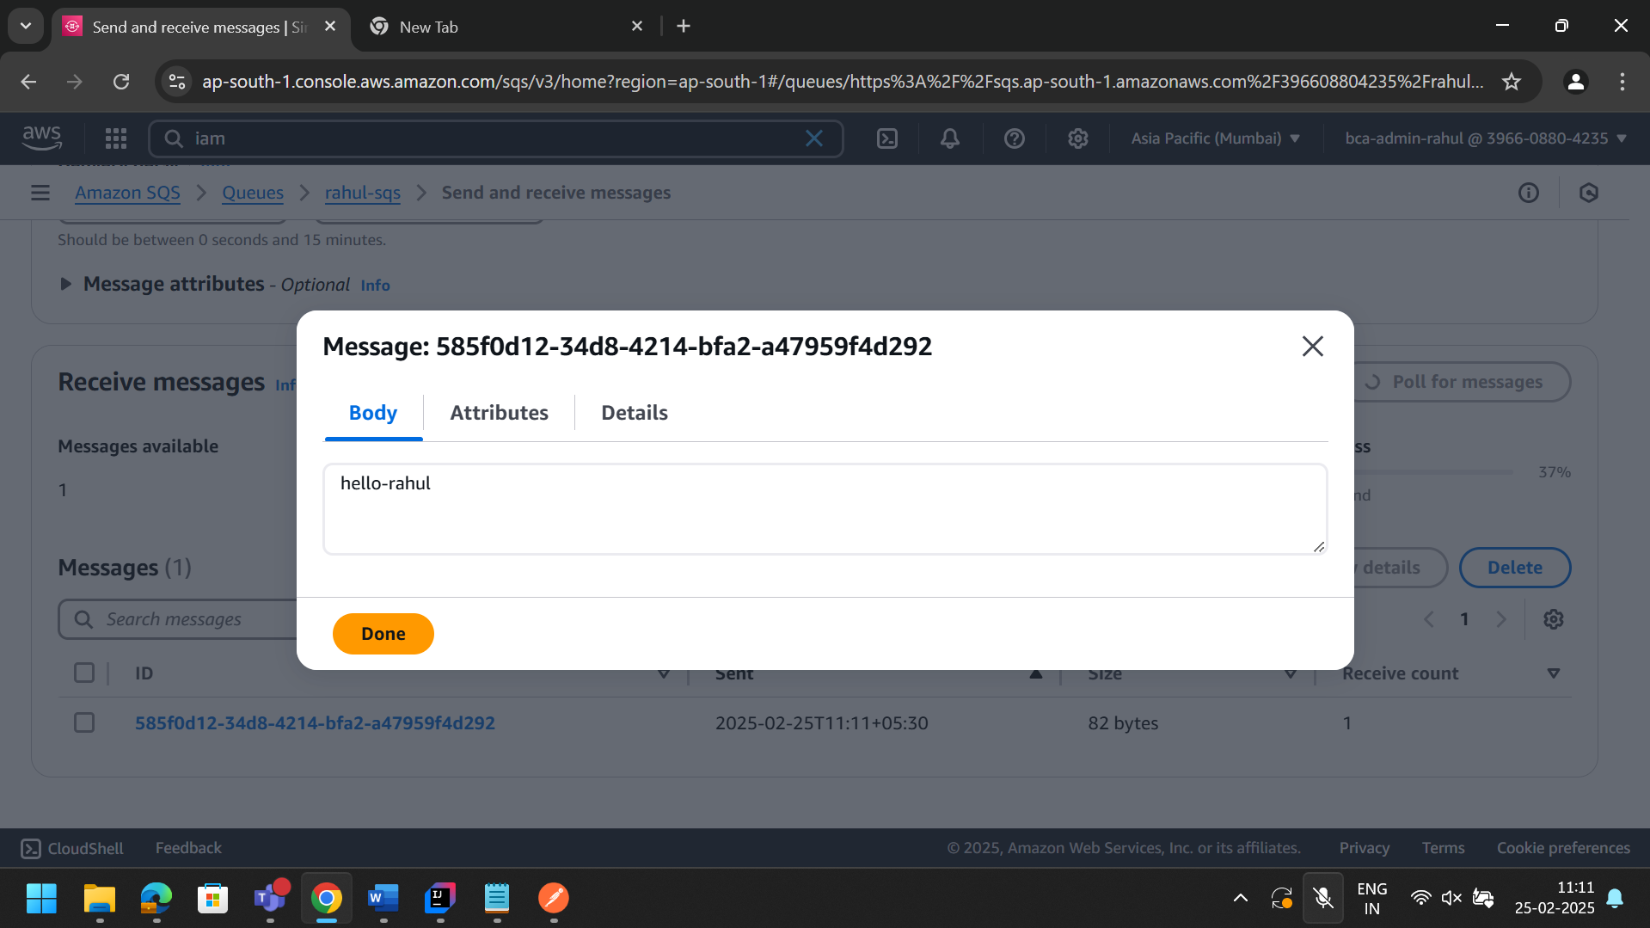

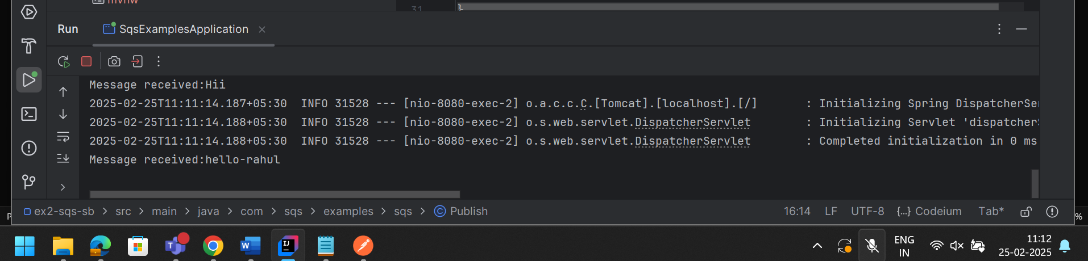

What is SNS?
Amazon Simple Notification Service (SNS) is a fully managed messaging service
from AWS that enables developers to send notifications to various subscribers
through channels like email, SMS, and mobile push notifications, using a publish-subscribe (pub/sub) model

Instruction:
1: first create topic with some name
2: Create substribtion and provide email of the client
3: Publish message it will be automcatically recived by the subscribers
4. Create Spring boot SNS application and Run the application and observe message is send to all subscribers

SNS WITHOUT SPRING BOOT

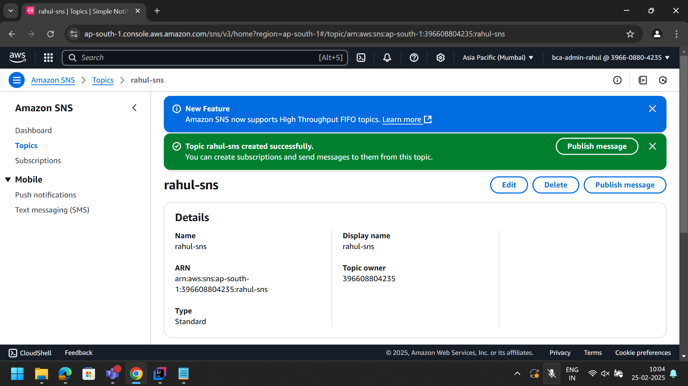

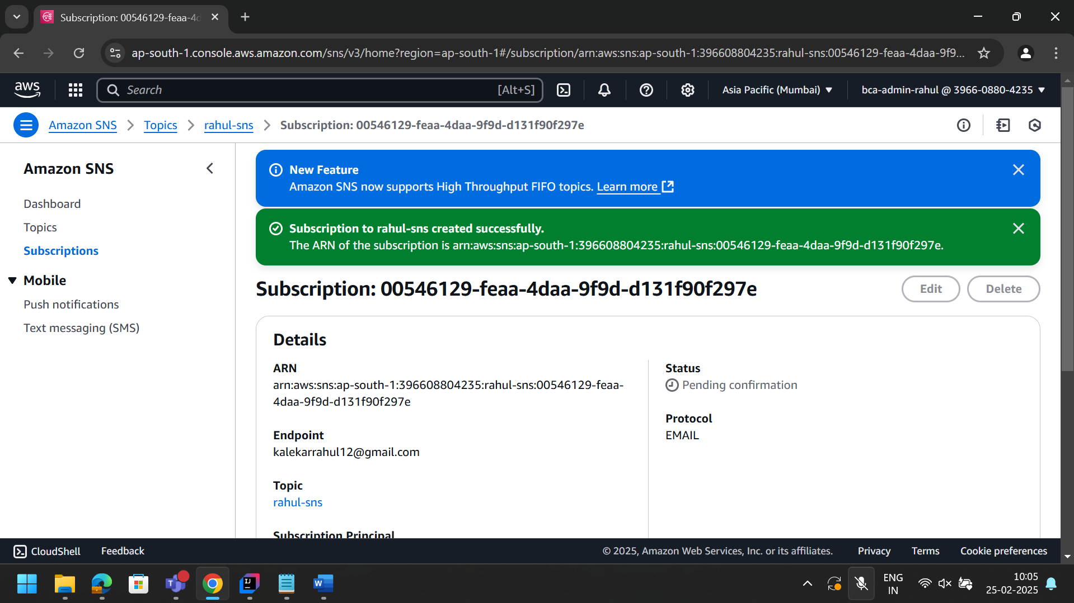

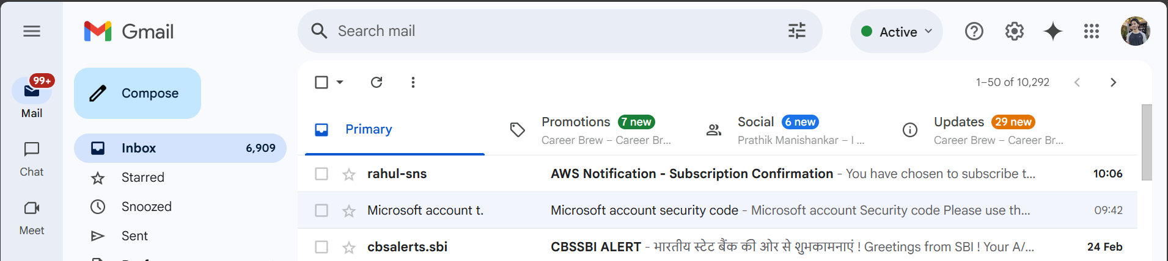

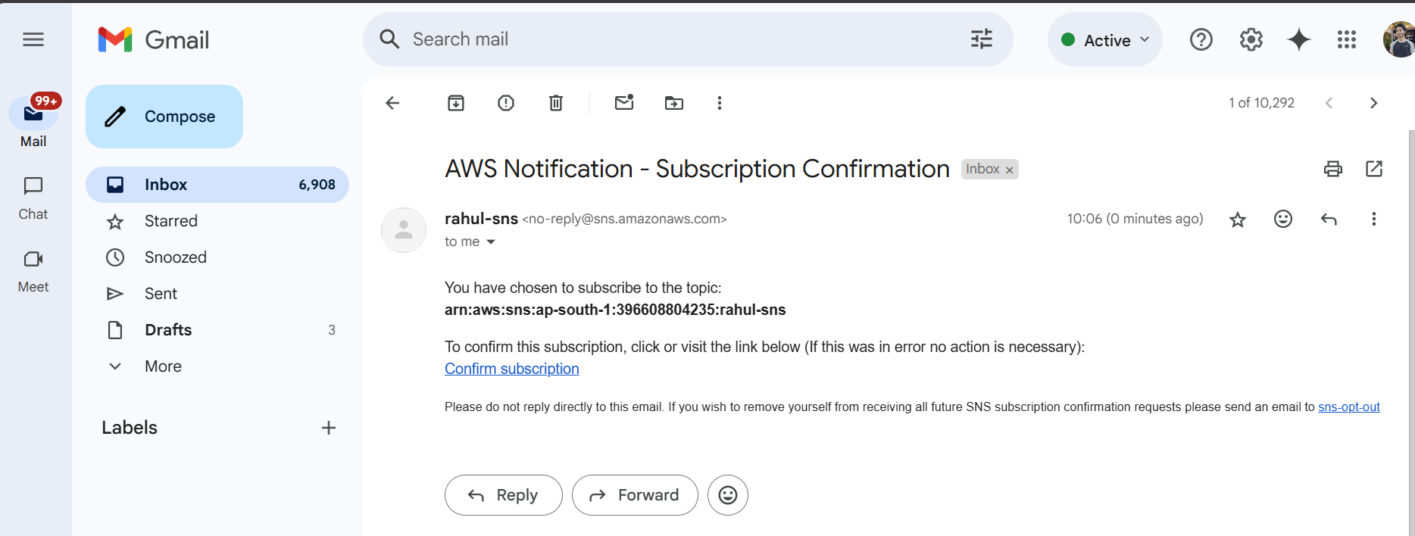

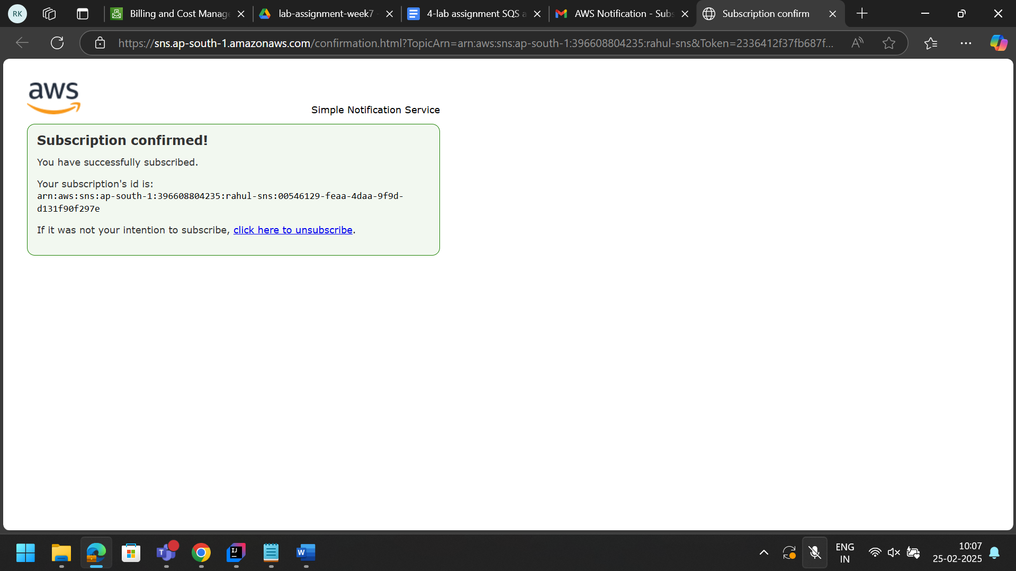
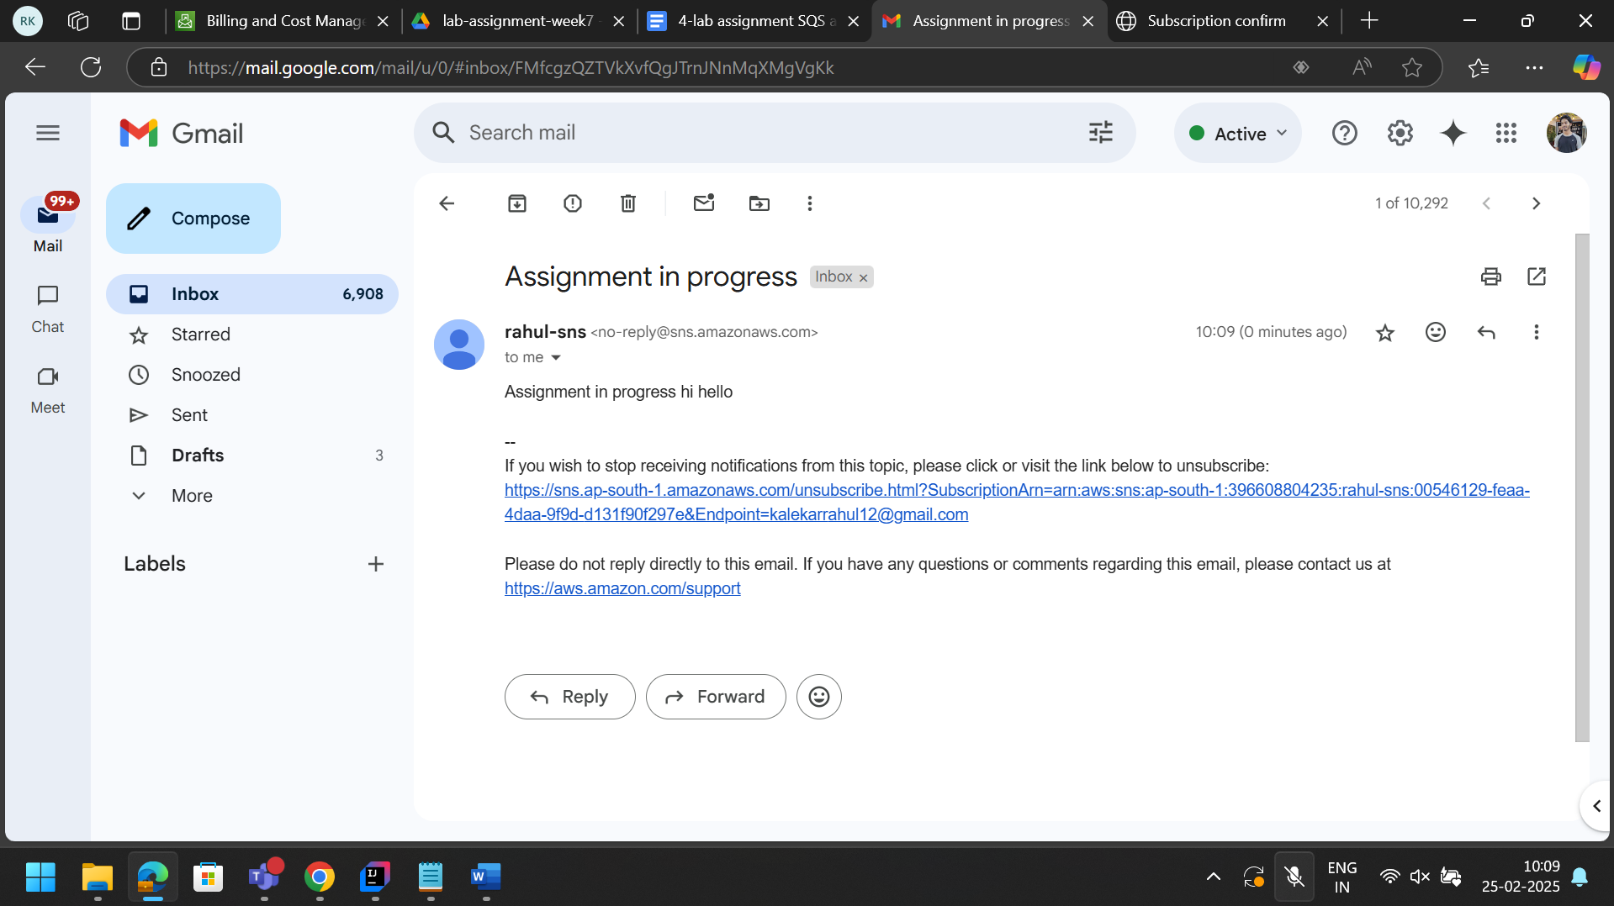

SNS WITH SPRING BOOT

